SUMMARY
- Having 7+ years of Strong Experience as DevOps Engineer in automating, building, releasing of code from one environment to other environment and deploying to servers.
- Extensively worked on the Agile Scrum based projects.
- Involved on all stages of Build and Release Management.
- Proficient in automating the Build and Release cycle using Jenkins.
- Created the complete CI/CD pipeline through Jenkins.
- Good knowledge of using groovy for creating Jenkins files.
- Utilized Kubernetes, Docker for the runtime environment of the CI/CD system to

build, test and deploy.
- Implemented microservices using Docker.
- Well versed in creating the Development Environment & QA Environment using
Docker Containers.

Good working experience on Kubernetes cluster environment and deploying the microservices into cluster environment. Autoscaling of pod, rolling update and Rolling back the microservices.
- Widely used Docker compose for creating the DEV & QA & PROD Environments.

Used version controlling tools like Git, SVN.
- Performed Configuration Management using Ansible.
- Good Experience in creating Ansible Playbooks for remote server management

and to install packages on different environments.
- Well versed in configuring build tools like Maven etc.
- Experience in using Splunk, Nagios for remote server monitoring.
- Working Experience of creating Infrastructure on AWS Cloud.
- Strong analytical and Problem-solving skills, strong organizational skills.
- Experienced in creation of technical, functional and requirement documentation.
- Quick learner with strong communication and people skills who can work in a
team or independently.

SKILLS PROFILE
Operating Systems : Red hat & Ubuntu Linux, Windows 8,10.
Services : SSH, NFS, Samba, HTTP Application Servers : WebSphere, Tomcat, JBOSS Web Servers : Apache, Ngnix
Database : MySQL, MongoDB, Redis
Version Tools : SVN, GIT, Bit Bucket
Ticketing Tools : JIRA, BMC Remedy and Service Now
Build Tools : ANT and Maven
Monitoring Tool : Nagios, Splunk,NetData, ELK

Scripts : Shell and Batch, Groovy, Python
Cloud : AWS & Azure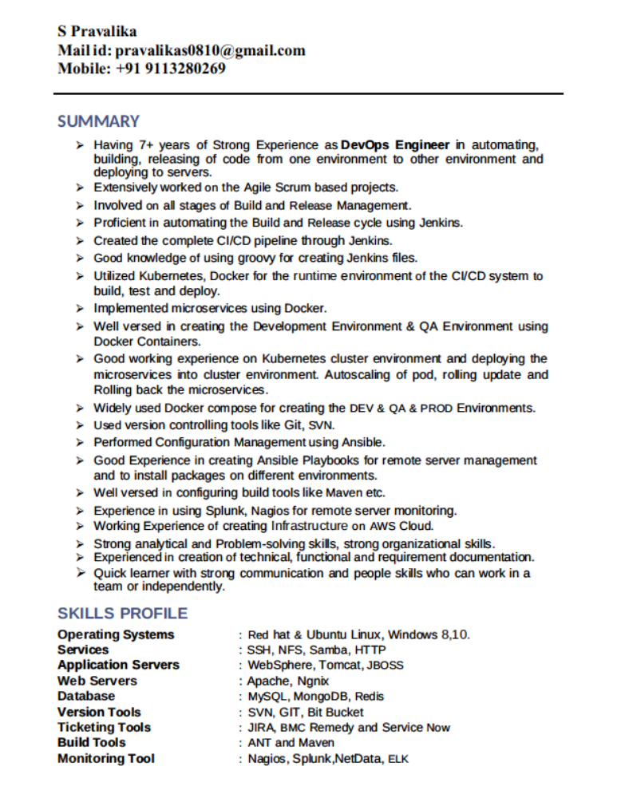
Devops Tools : Jenkins, Ansible, Chef, Docker, Kubernetes,
OpenShift
ETL : Informatica 8.X/9.X

PROFESSIONAL EXPERIENCE

- Working as Consultant in Capgemini India Pvt Ltd, Bangalore from
January’15 –Till date.
EDUCATION DETAILS:
- BBM – from Sri Krishnadevaraya University.
BT Group plc, UK April’15 – Till date
Role: DevOps Engineer

BT Group plc (trading as BT and formerly British Telecom) is a
British multinational telecommunication holding company headquartered in London, United Kingdom. It has operations in around 180 countries and is the largest provider of fixed-line
, broadband and mobile services in the UK, and provides subscription television and IT
services.

Roles & Responsibilities:

- Creating and building Docker images, containers and writing docker file to create custom images and issue troubleshooting and Implemented Microservices using Docker.
- Resolving issues and continuous improvement of Dockerized environment both

on dev, QA, pre-production and Production Environment.
- Implemented Master–Slave concept in Jenkins to achieve Load Balancing.

Implantation of Jenkins pipeline job configurations and access permissions for
various groups and issue troubleshooting for pipeline jobs.
- Debug and resolve issues related to Jenkins job failures, job permissions and

involved in Jenkins master slave architecture related issues resolution
- Planning and Implementation of VM’s and Databases on Azure Public cloud,
MySQL, MongoDB and Redis Database.
- Configuring, Load Balancing and Monitoring DevOps Infra on Azure Public Cloud using Azure Application Gateway (WAF, HTTP settings, Rules, Listeners, Backend pool), App services, VM, Azure Storage, Azure Security.
- Implementation and troubleshooting MYSQL InnoDB cluster for all DEV, UAT,
PROD environments.
- Managing infrastructure using AWS cloud (RDS).
- Creating Virtual hosts and Pointing to DNS.

- Responsible for installation & configuration of Jenkins to support various Java builds and Jenkins plugins to automate continuous builds and publishing Docker images to Docker-Hub repository.
- Containerized all related applications- Spring Boot Java and NodeJS applications
using Docker.
- Used Jenkins and pipelines to drive all microservices builds out to the Docker

registry and then manage and deploy to Kubernetes, OpenShift environment.
- Executing YAML file to create Pods, Deployments, Services and Generating
secrets to access some Docker-hub Registry and Databases.
- Creating RBAC for users in Kubernetes cluster.
- Execution of shell scripts from Jenkins jobs for builds at DEV, QA, UAT, PACKAGE
and DEPLOY level.
- Configuring, troubleshooting MySQL InnoDB clusters, MySQL Replication,
MongoDB and Redis databases.
- Installation, Configuring and Troubleshooting Web Servers like Nginx, HTTP,

Apache2 and IIS.
- Configuring and Monitoring Logs using ELK, Nagios and Splunk Enterprise.
- Worked closely with QA Teams, Project Teams and Product Operations teams to
identify QA and UAT cycles release schedule to non-prod and prod environments.
- Configured SonarQube in Jenkins that measure and analyze quality of source
code (JAVA)
- Configured Email Notifications in Jenkins after every successful and failed build.
- Involved in migration of Tomcat server from Tomcat Version 6 to Version 7.
- Managing and Monitoring Jenkins (Auditing, Project based Security, Authorization
and access management)
- Maintained build and deployment procedures and resolved configuration management issues, created Branches for each release for particular environment, making baselines and merging of branches using GIT.
- Used Maven and Ant as build tools to generate JAR, WAR and EAR and configured

in Jenkins to move files from one environment to another.
- Created Ansible playbooks and Chef Cookbooks to enable automation of

infrastructure deployment.
- Used Ansible for server provisioning and infrastructure automation, release automation and deployment automation, Configure files, commands and packages.
- Worked on deployments in Apache Tomcat, JBOSS and automated deployments
in DEV/QA/IST/STG/PROD environments.
- Communicated with all team while PROD release and deployed packages into Tomcat application server and ran system update and executed DB script in backed servers after every PROD Release.
- Created the Release notes along with the SCM team and released the Deployment
instructions to Application Support.
- Monitoring CPU utilization, JVM memory utilization, finding process id with port number and resolving port conflicts using various Linux commands.

